Họ tên : Lê Bá Khánh Trình

MSSV : 6151071108

Lớp :CNTT-K61

1. Write a PL/SQL block to calculate the incentive of an employee whose ID is 110.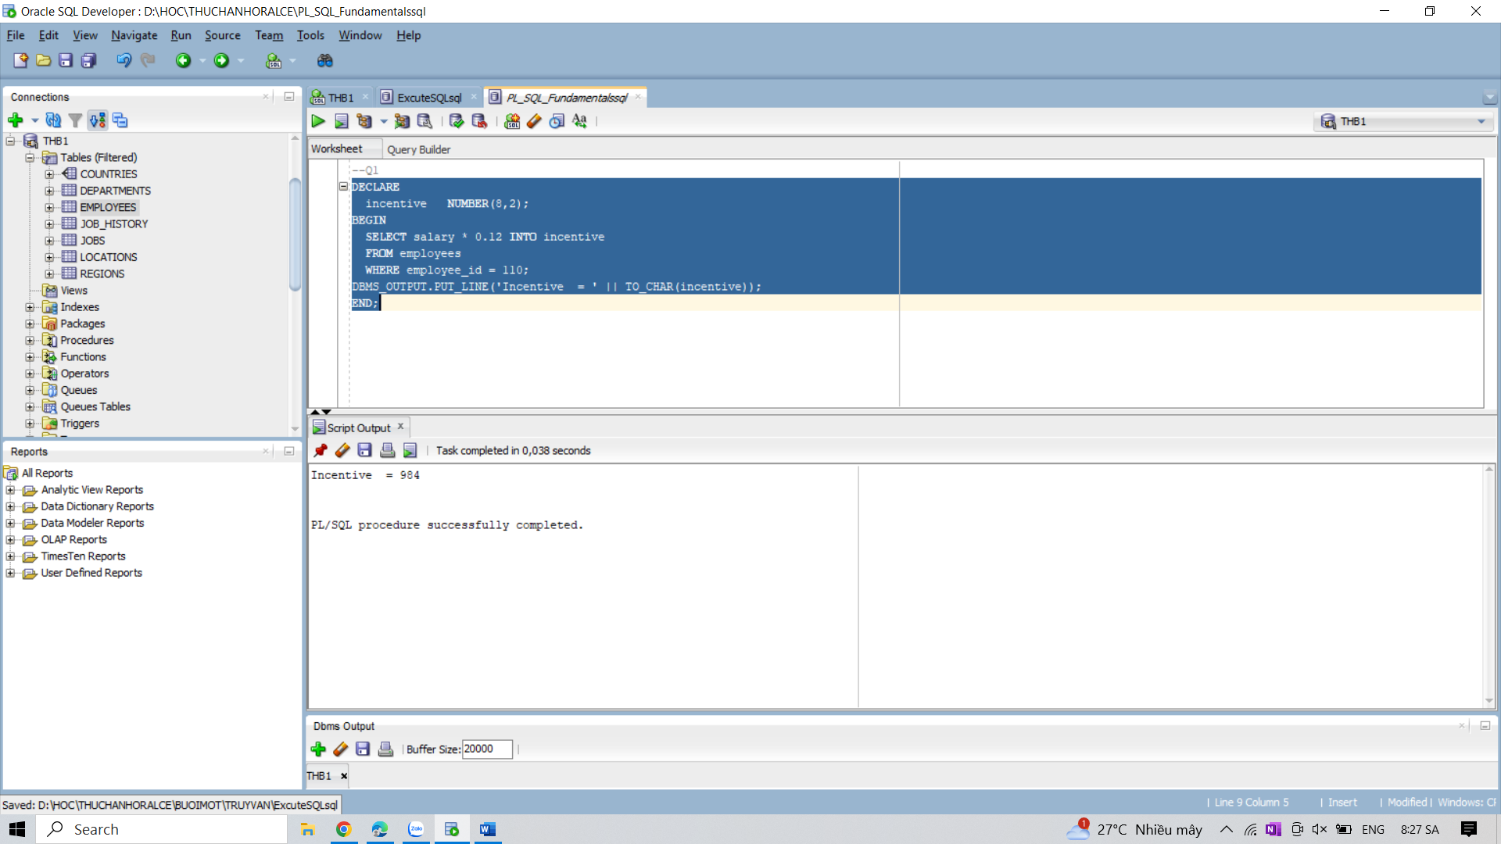

2. Write a PL/SQL block to show an invalid case-insensitive reference to a quoted and without

quoted user-defined identifier.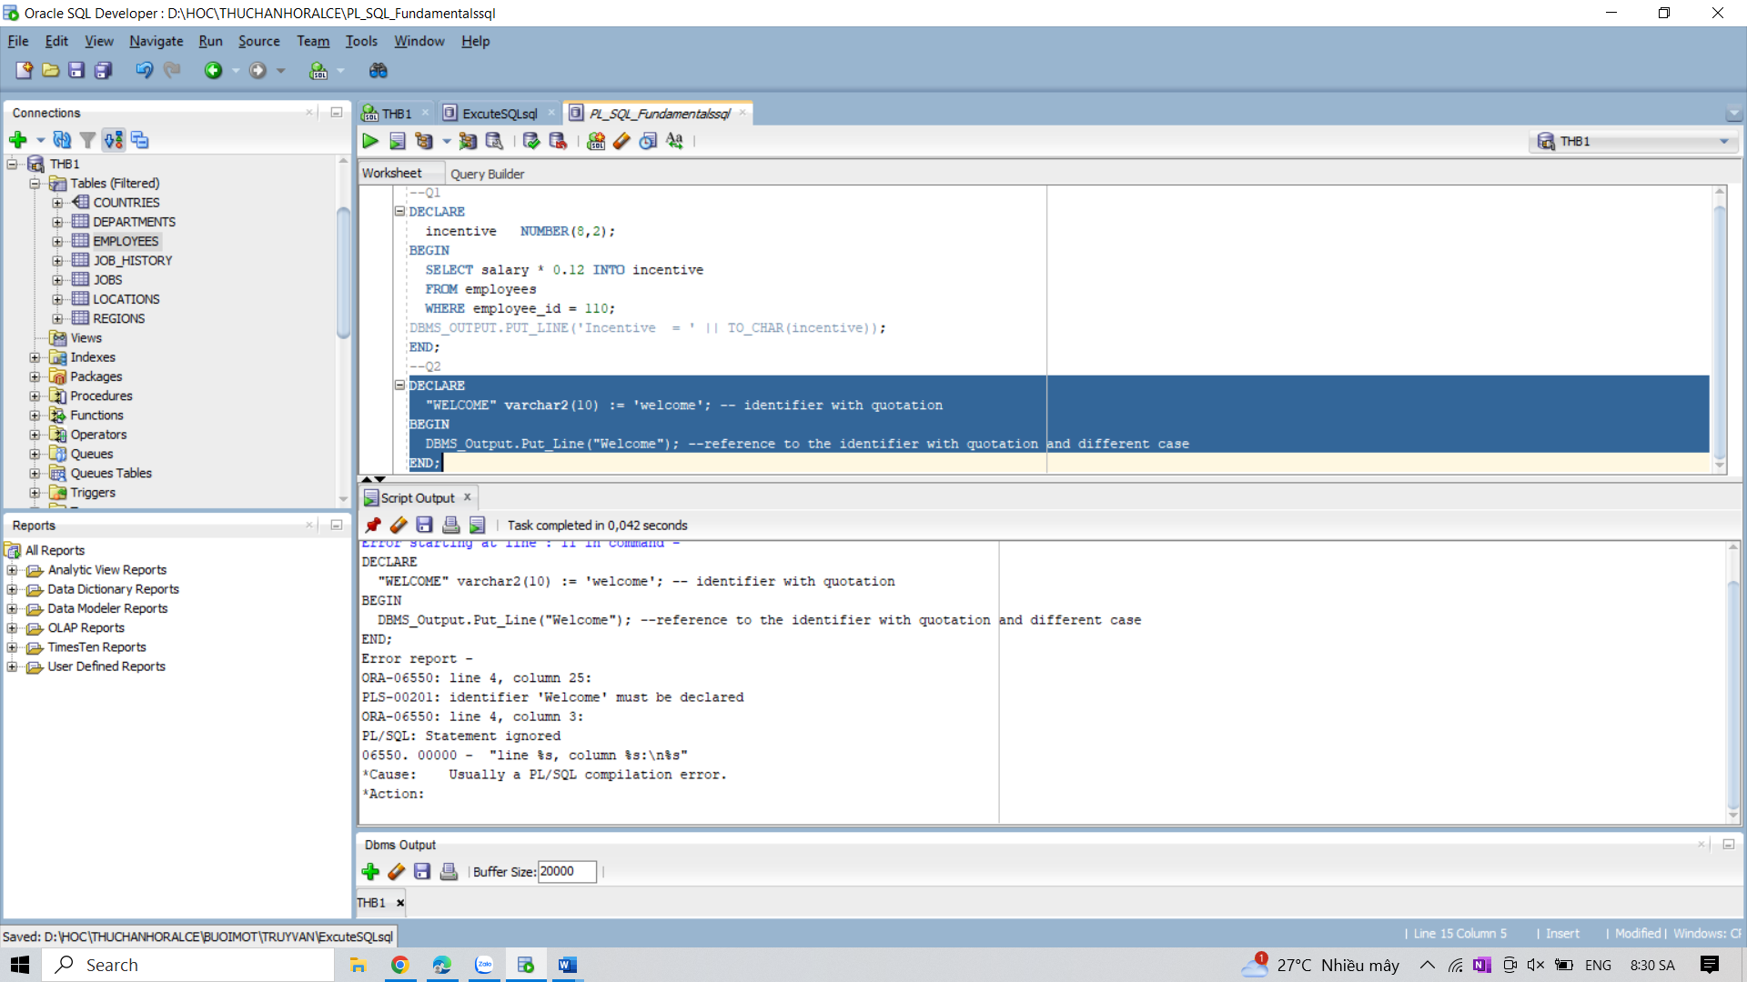

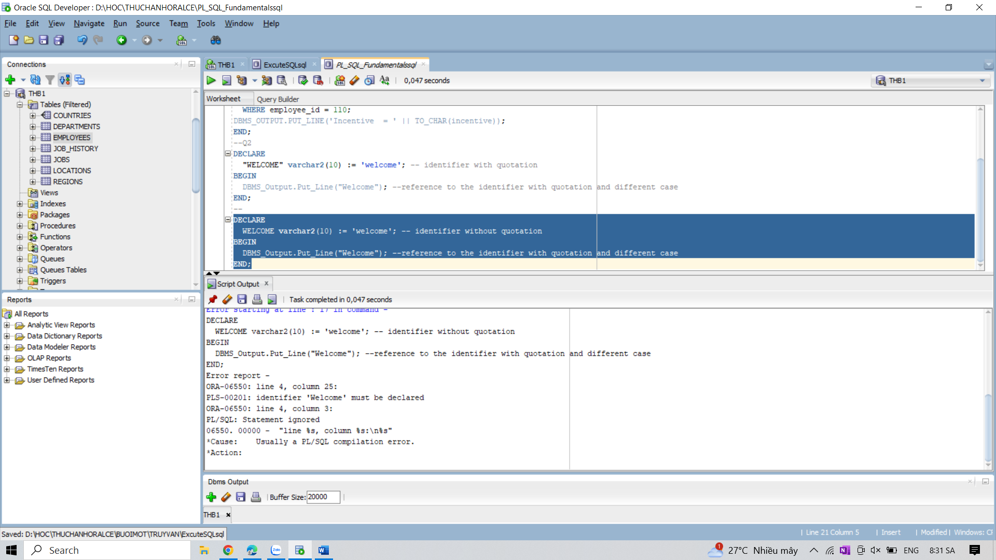

3. Write a PL/SQL block to show a reserved word can be used as a user-define identifier.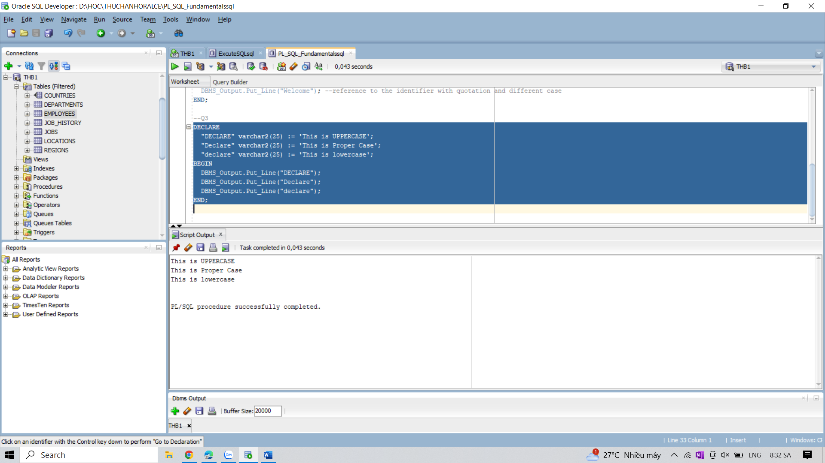

4. Write a PL/SQL block to show the result to neglect double quotation marks in reserved word

identifier.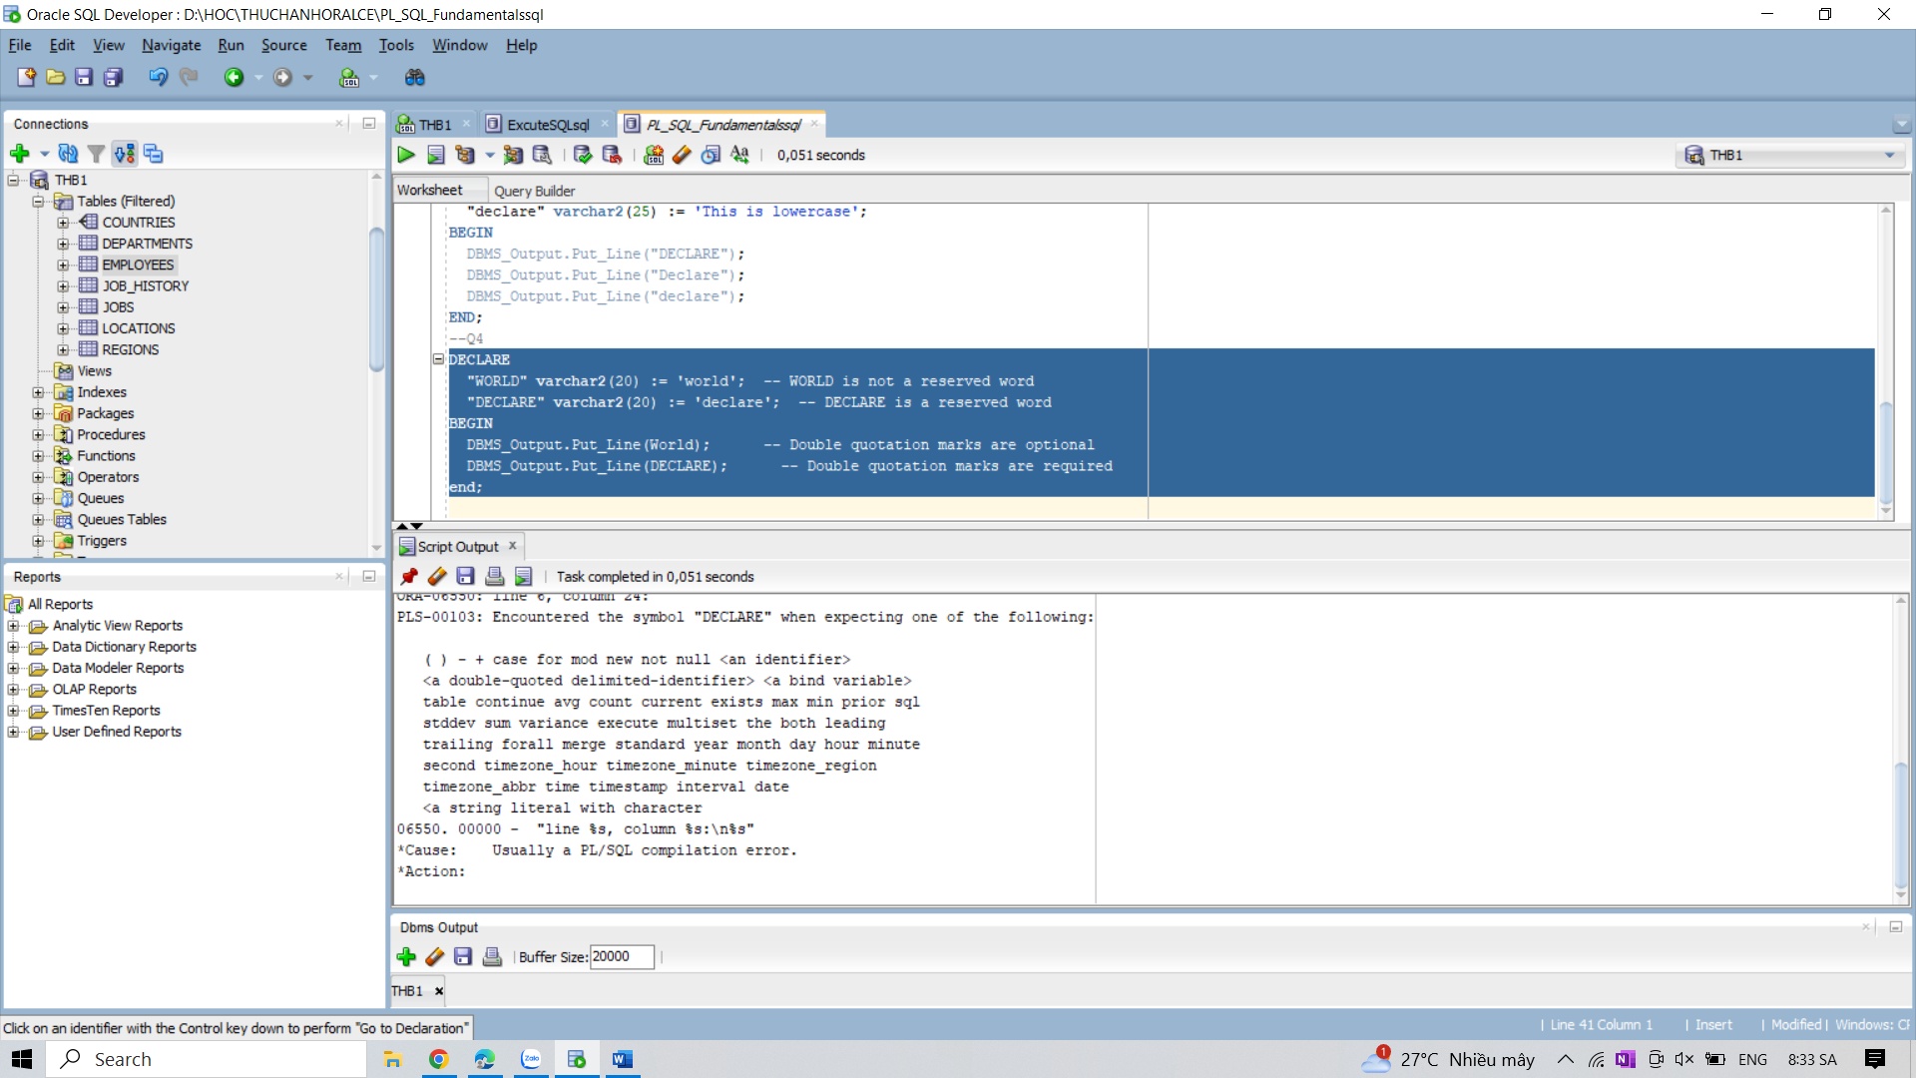

5. Write a PL/SQL block to show the result to neglect the case sensitivity of a user defined

identifier which is also a reserved word.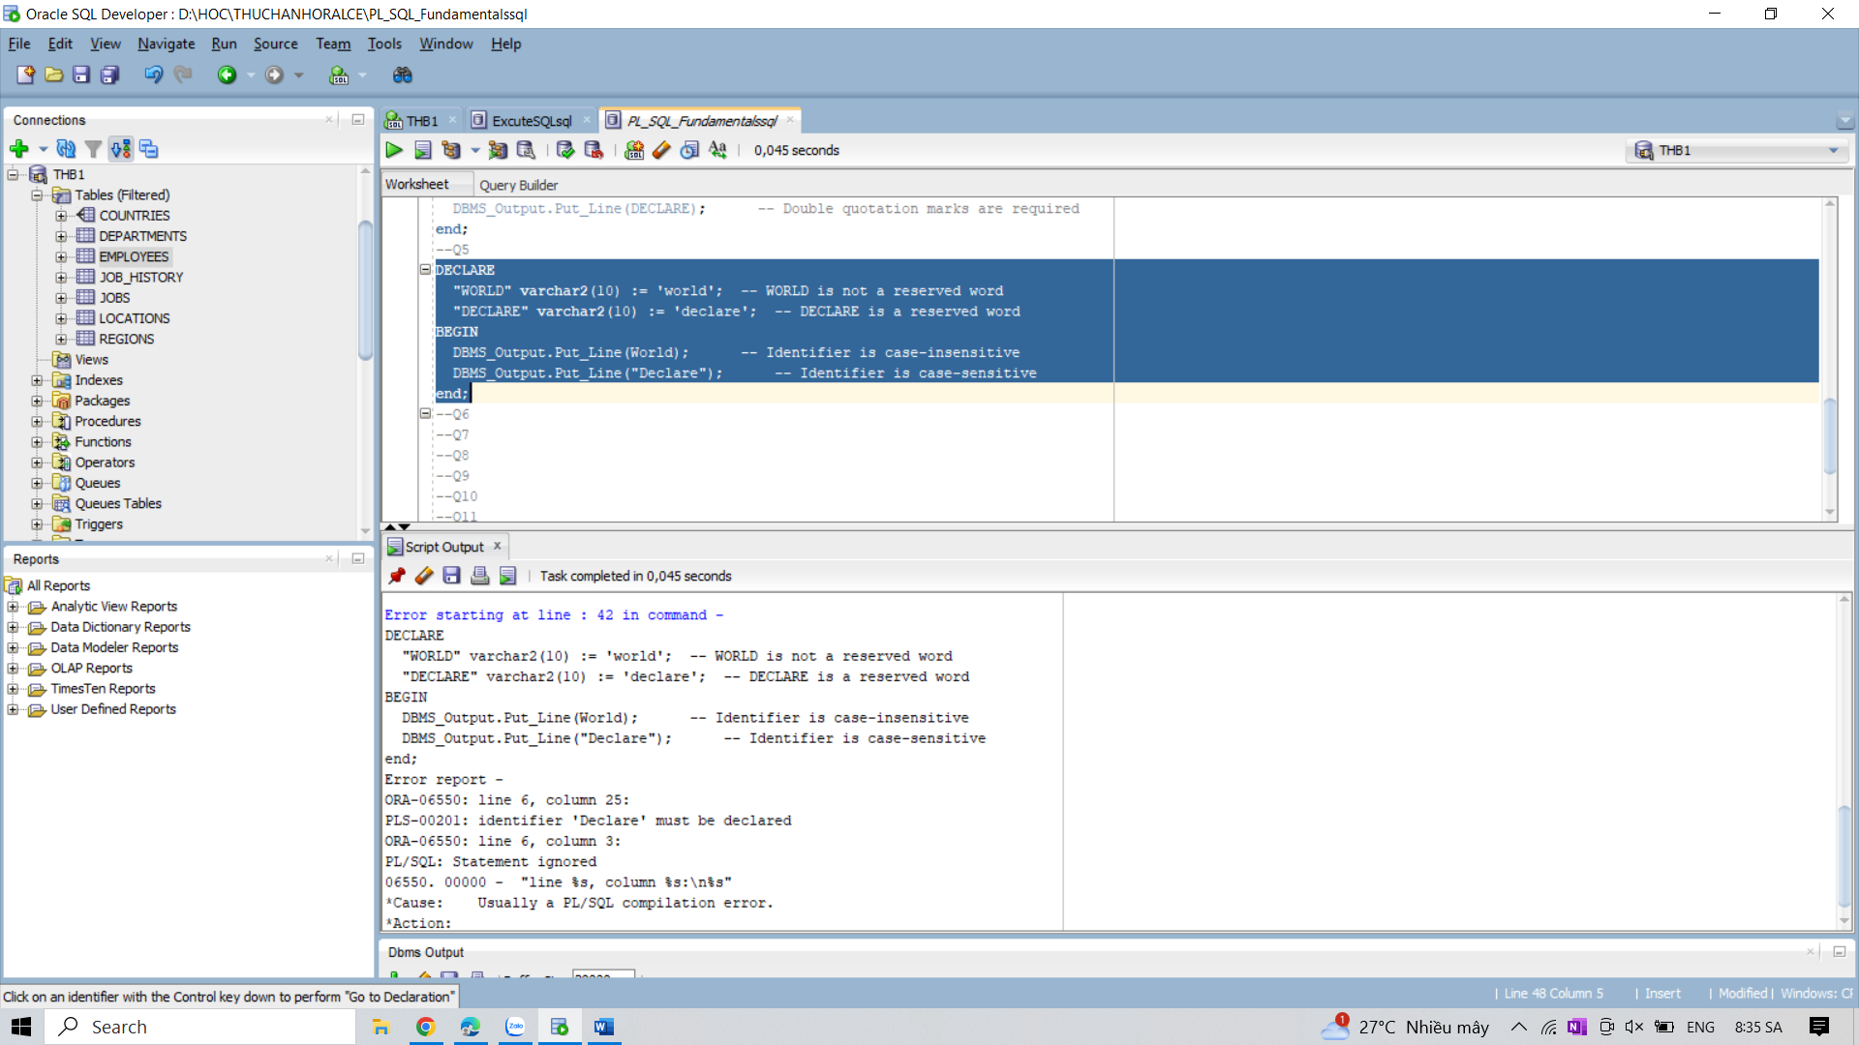

6. Write a PL/SQL block to explain single and multiline comments.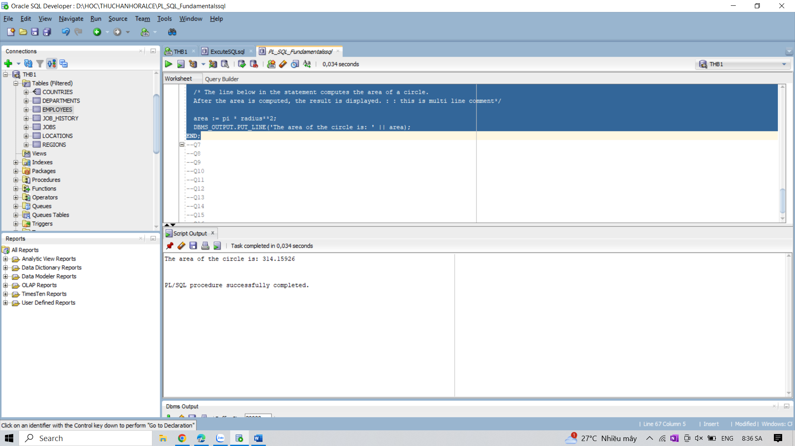

7. Write PL/SQL blocks to show the declaration of variables.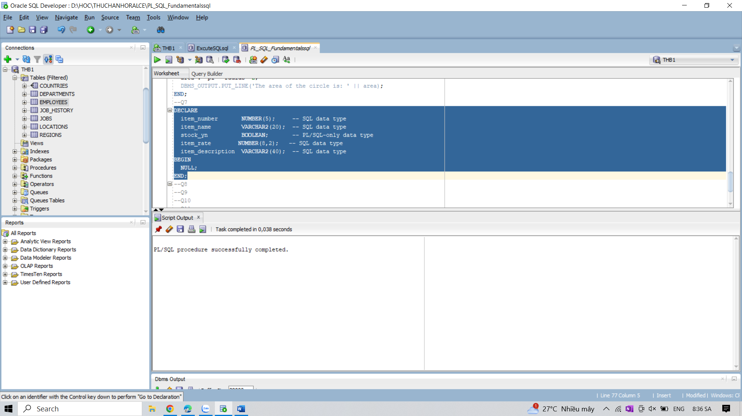

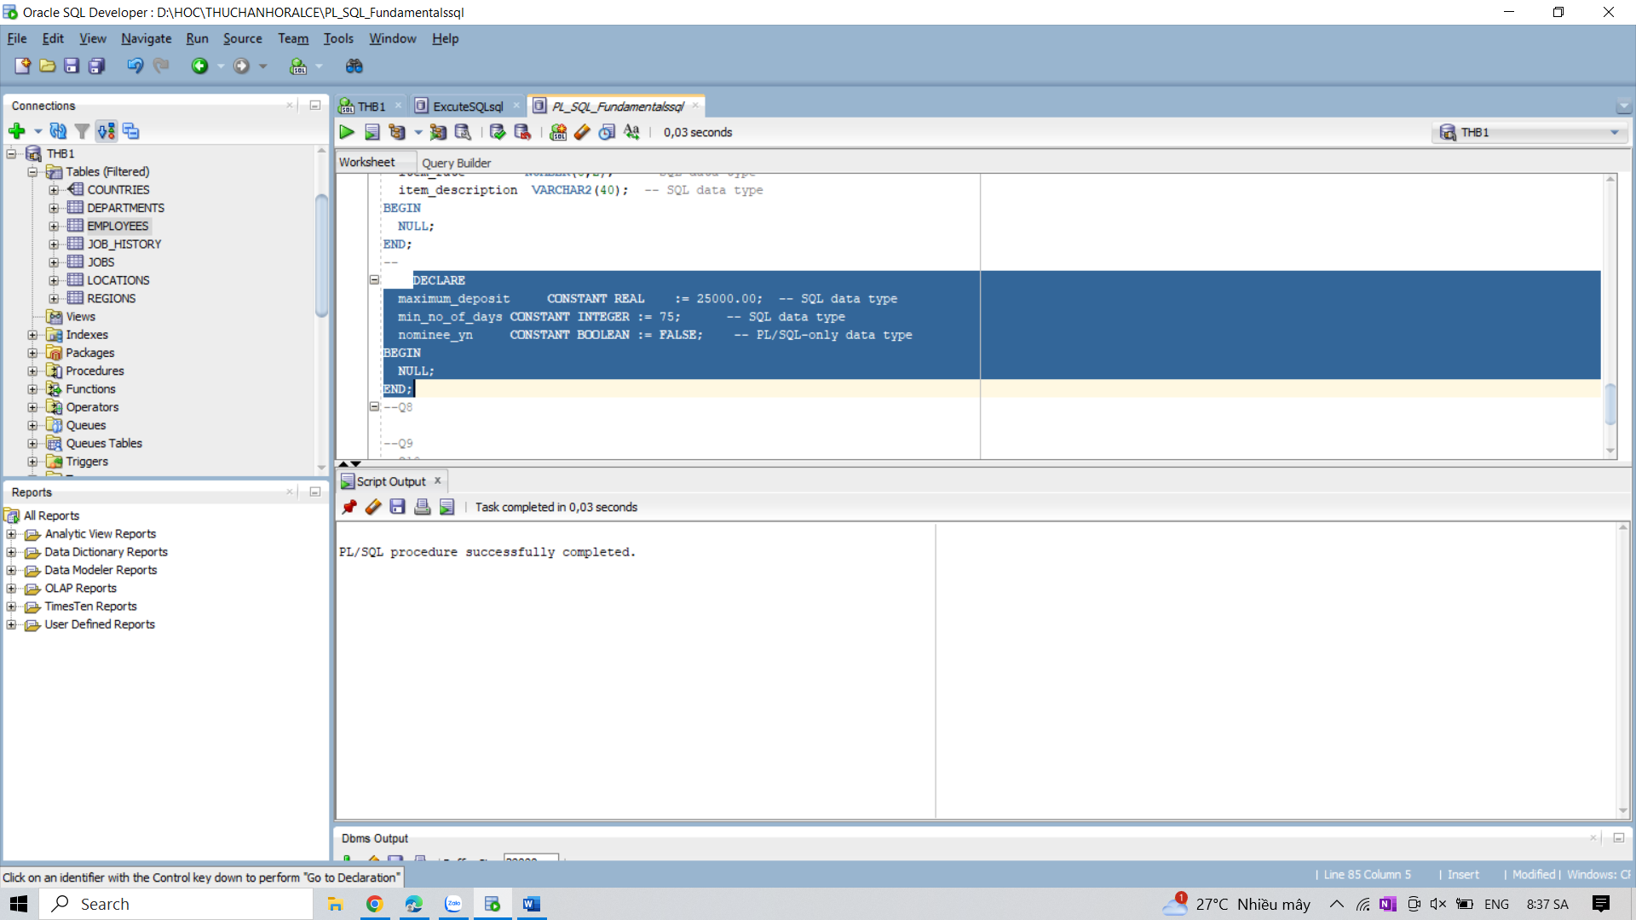

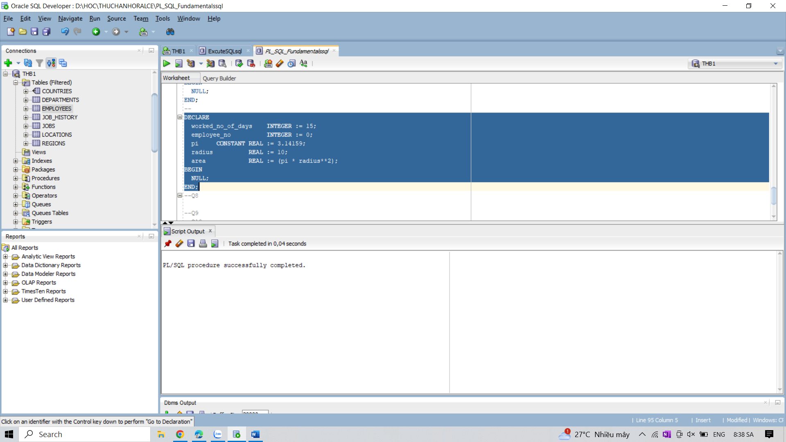

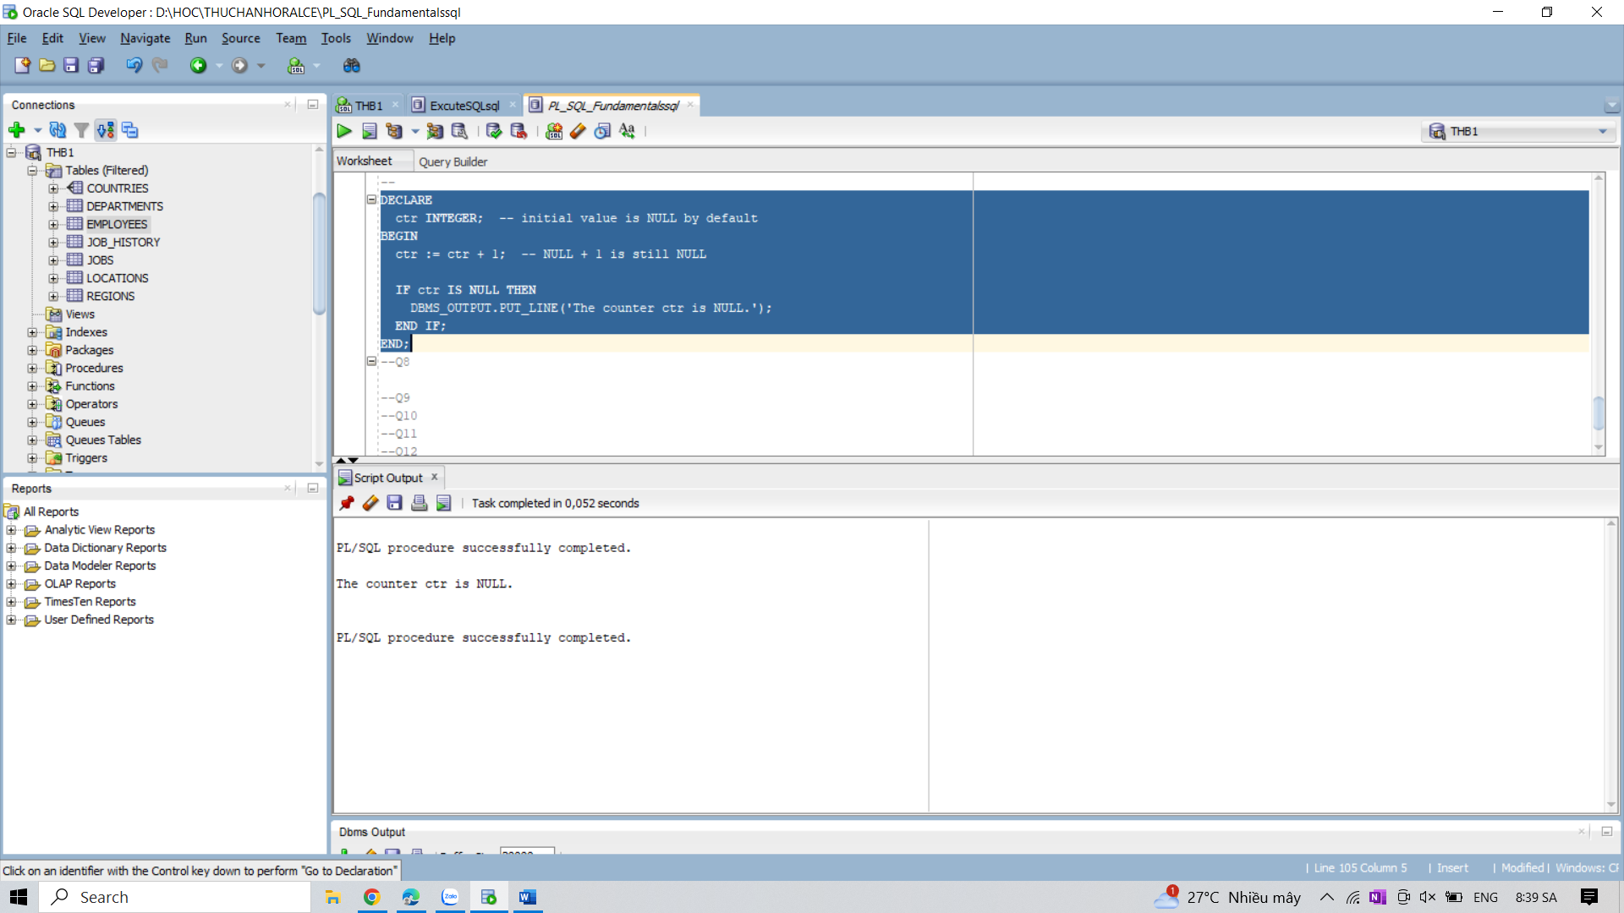

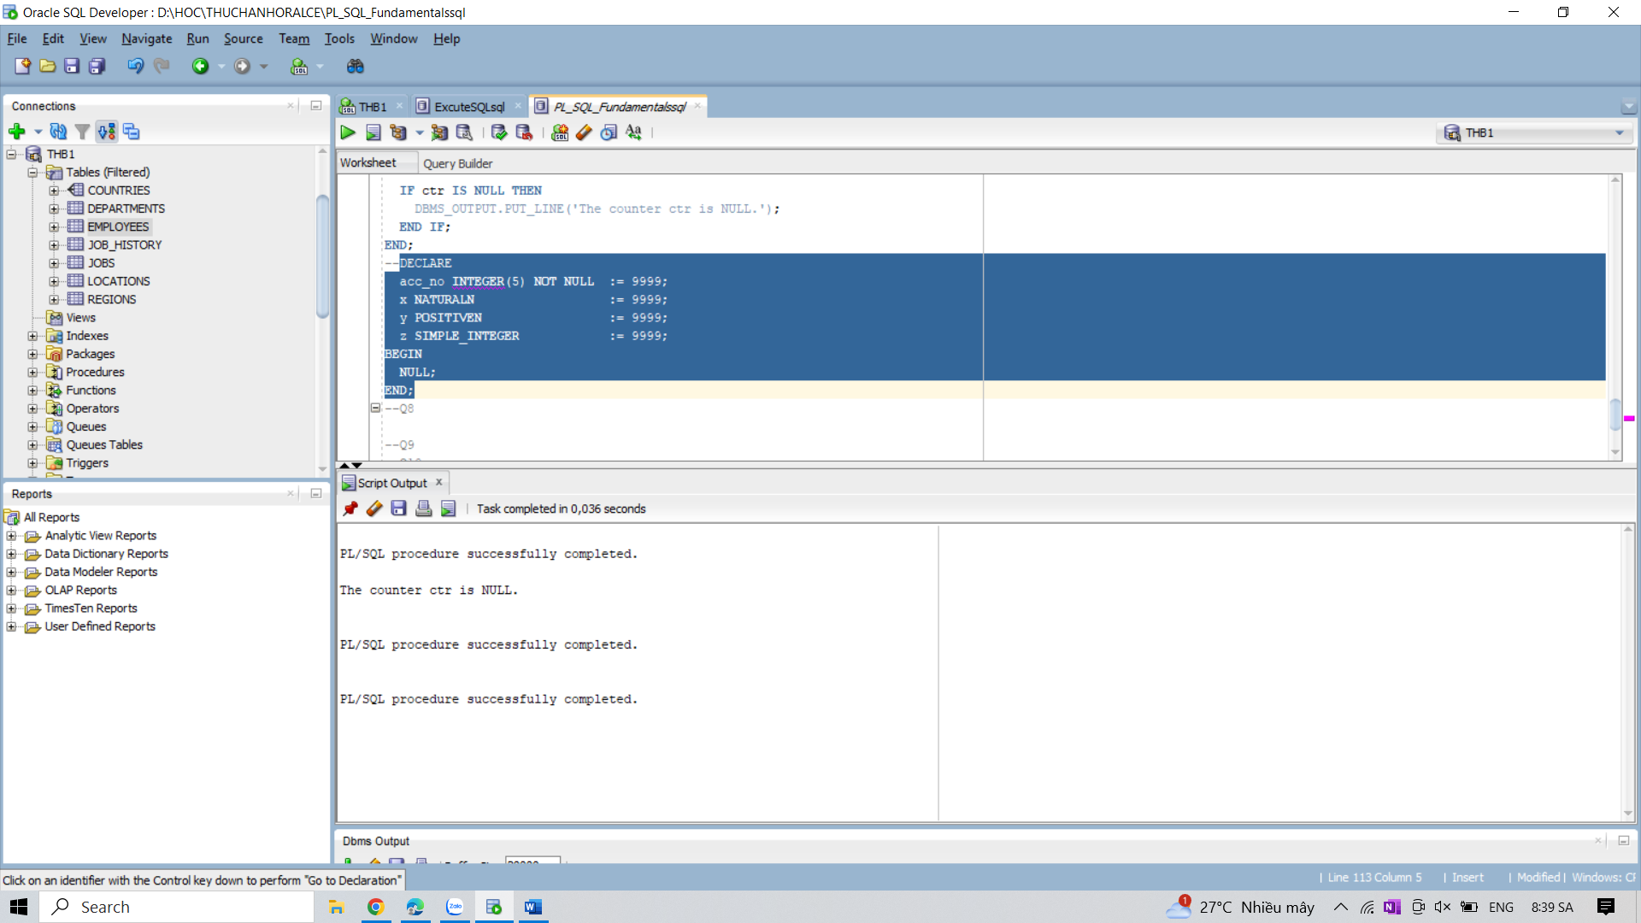

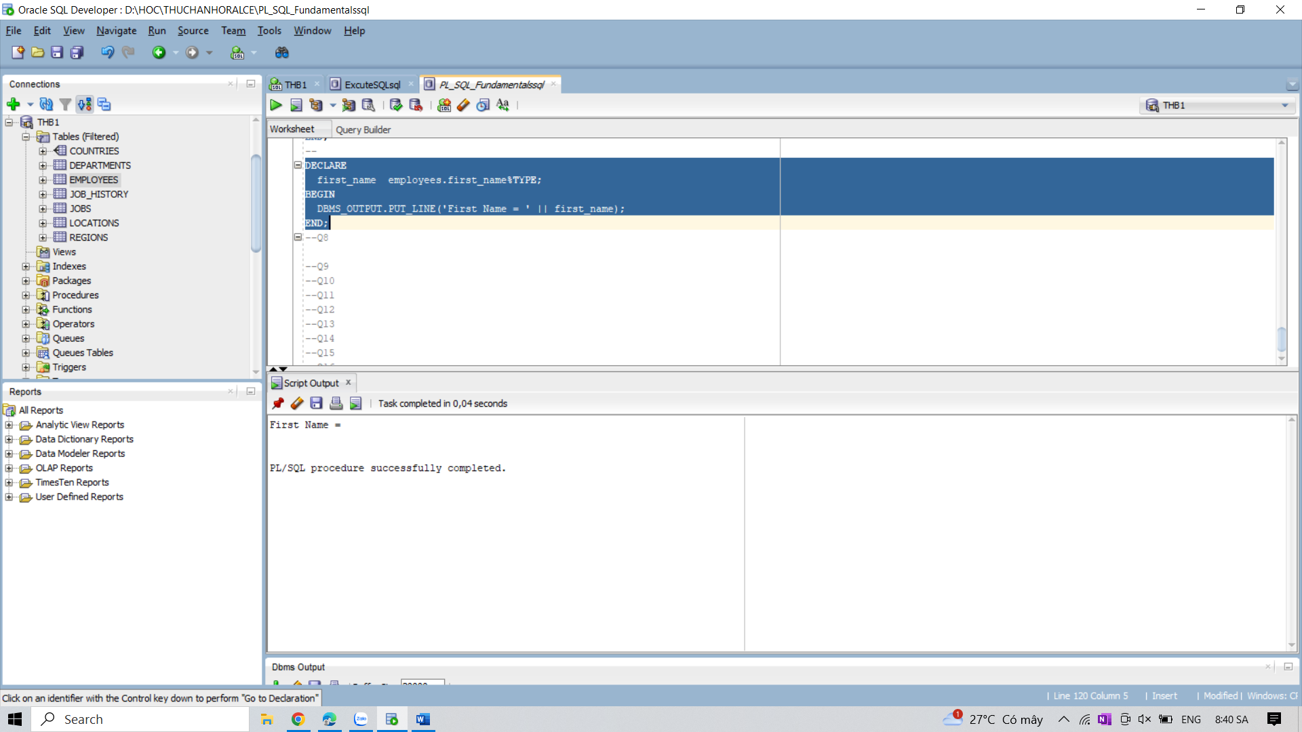

8. Write PL/SQL blocks to show the scope and visibility of local and global identifiers.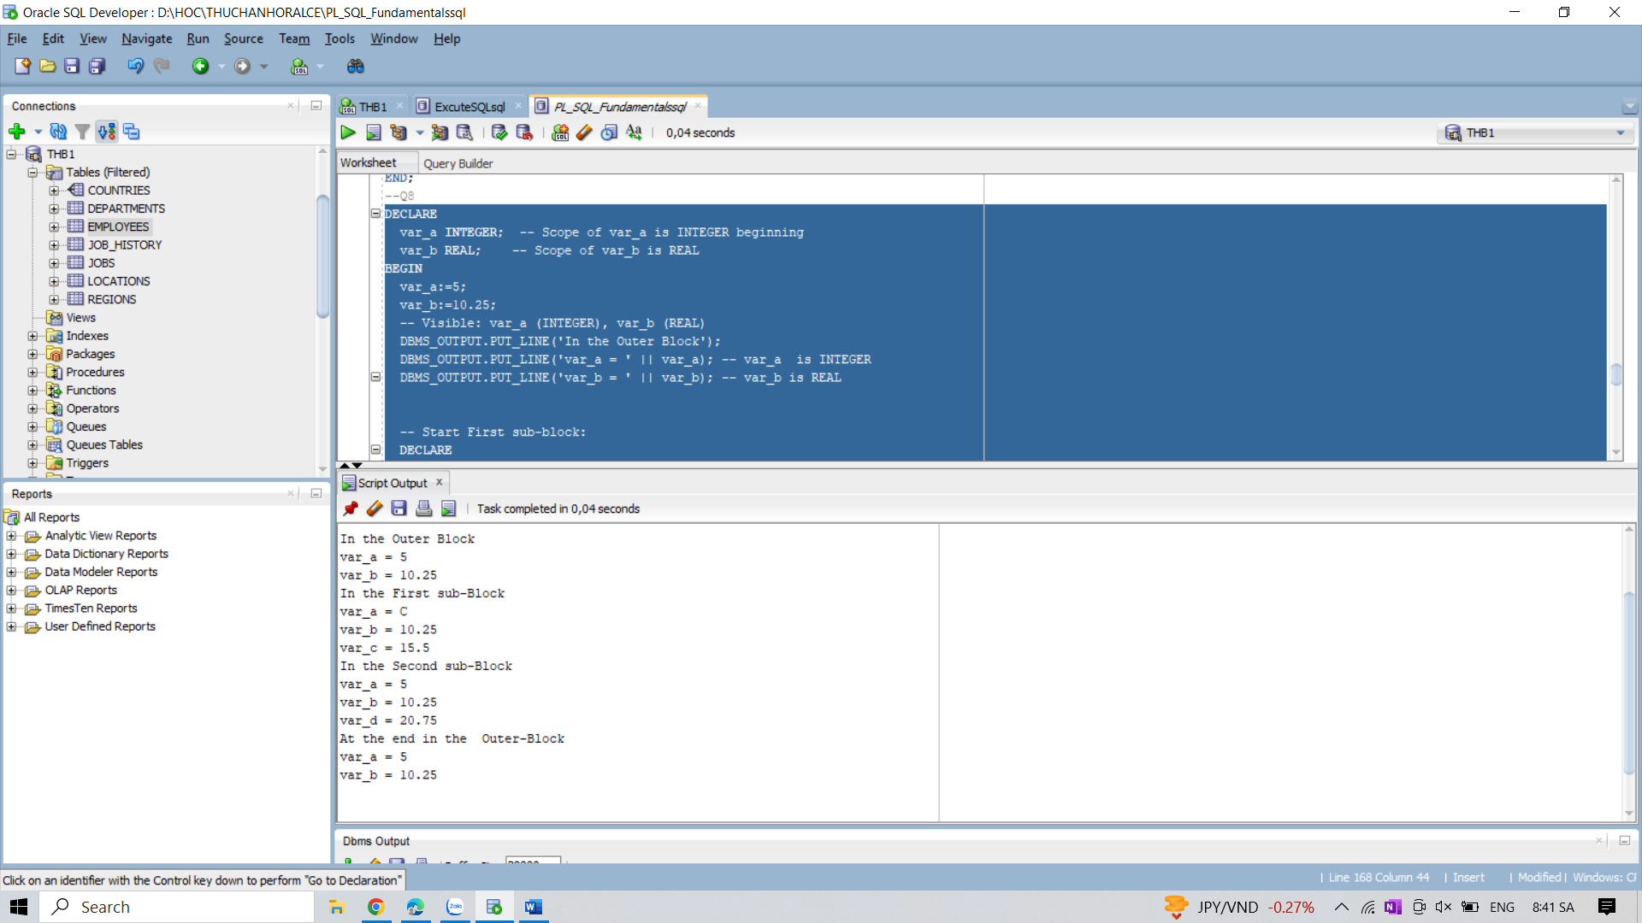

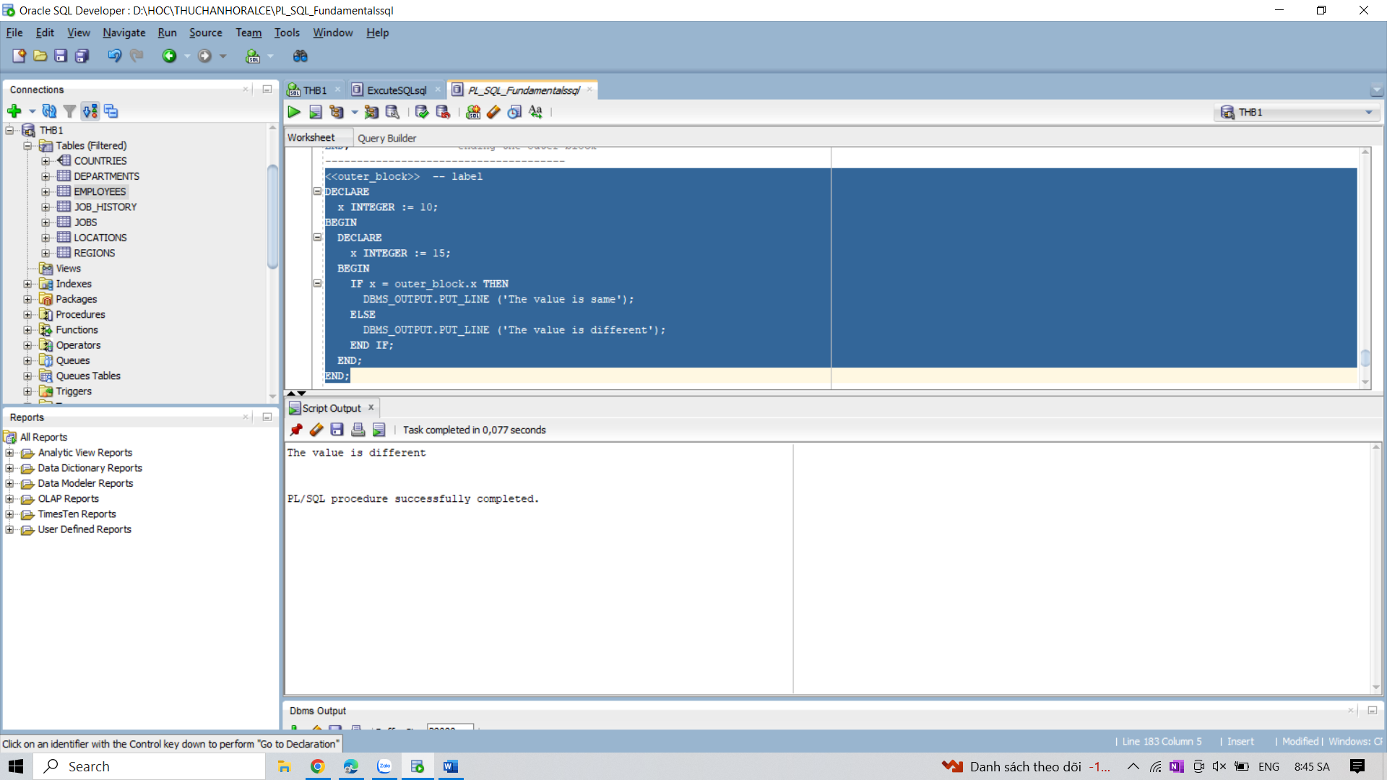

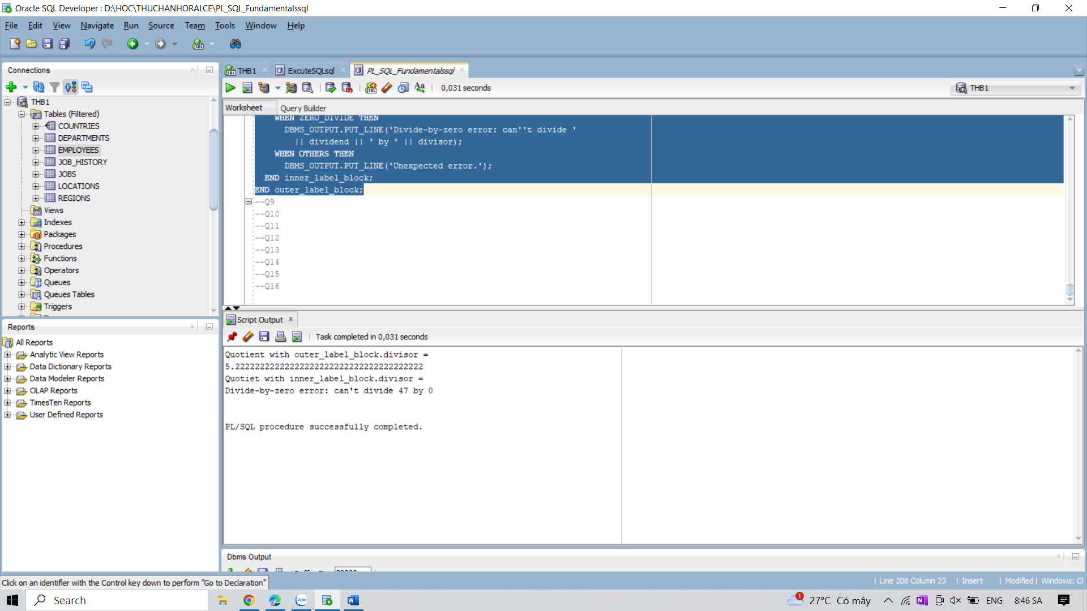

9. Write a PL/SQL block to show a valid case-insensitive reference to a quoted and without

quoted user-defined identifier.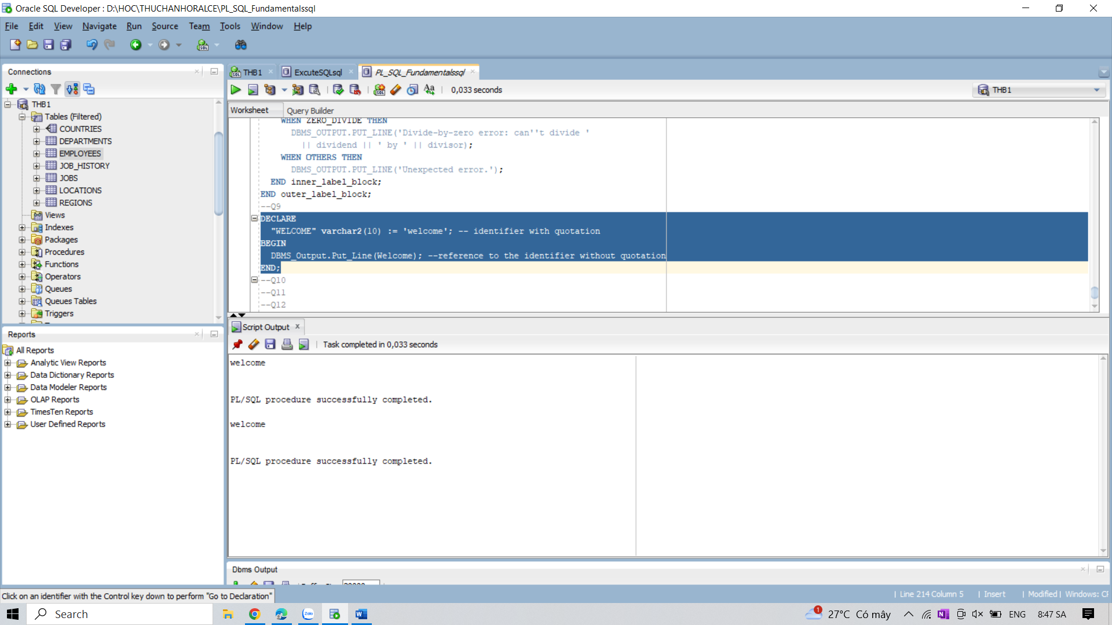

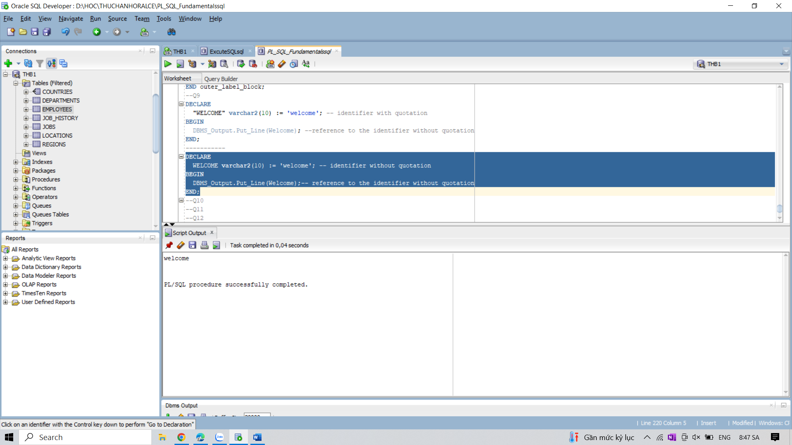

10. Write a PL/SQL block to adjust the salary of the employee whose ID 122.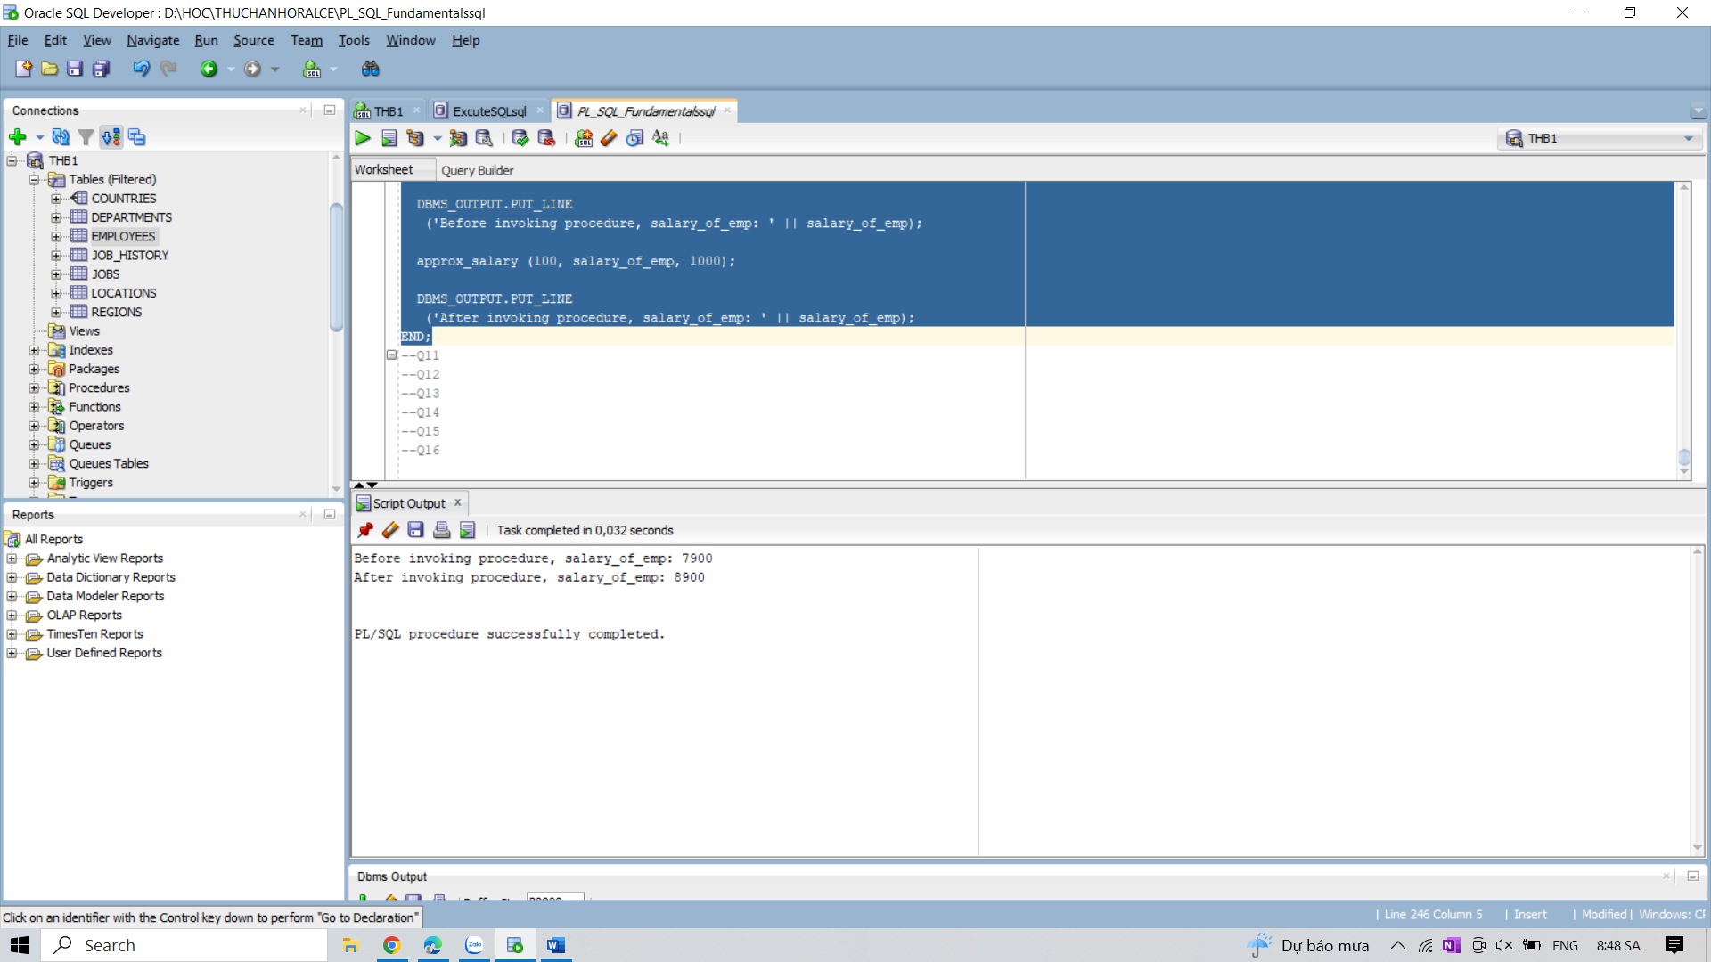

11. Write a PL/SQL block to show the operator precedence and parentheses in several more

complex expressions.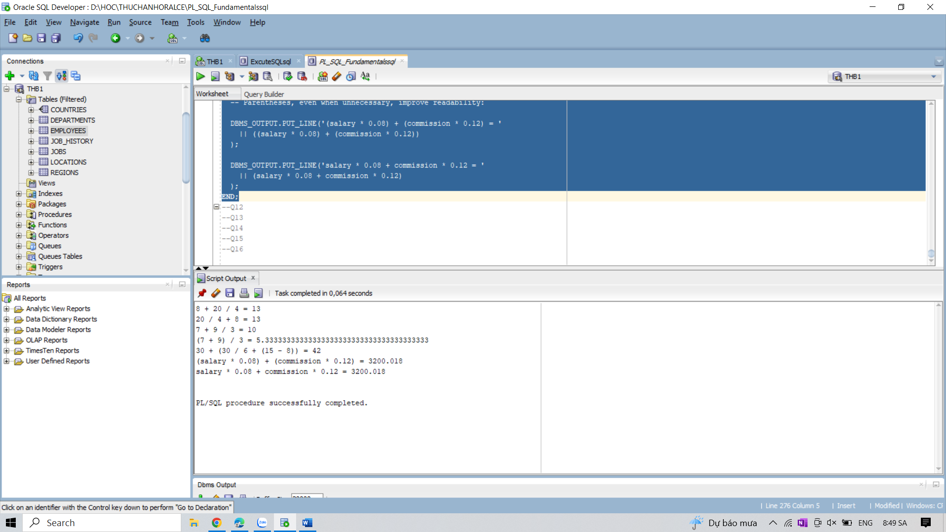

12. Write a PL/SQL block to create a procedure using the &quot;IS [NOT] NULL Operator&quot; and show

AND operator returns TRUE if and only if both operands are TRUE.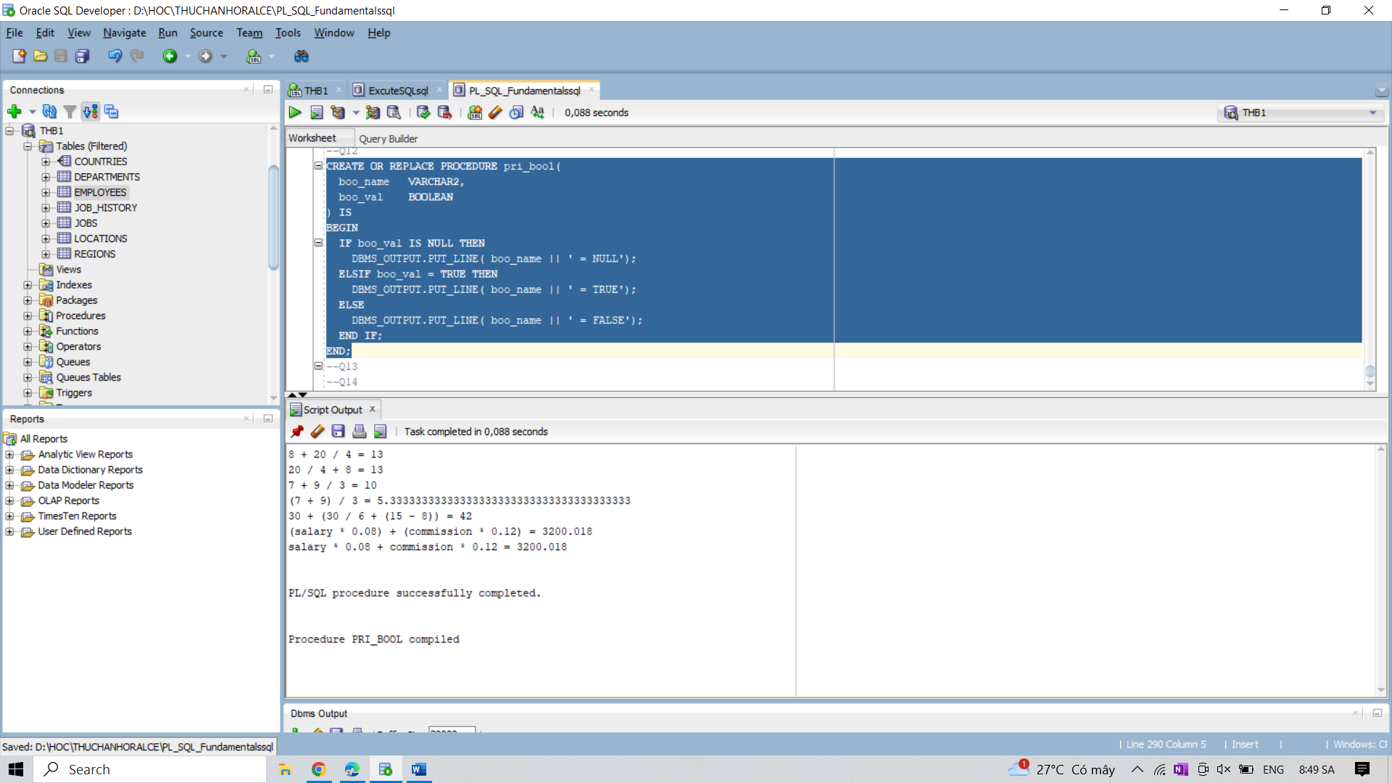

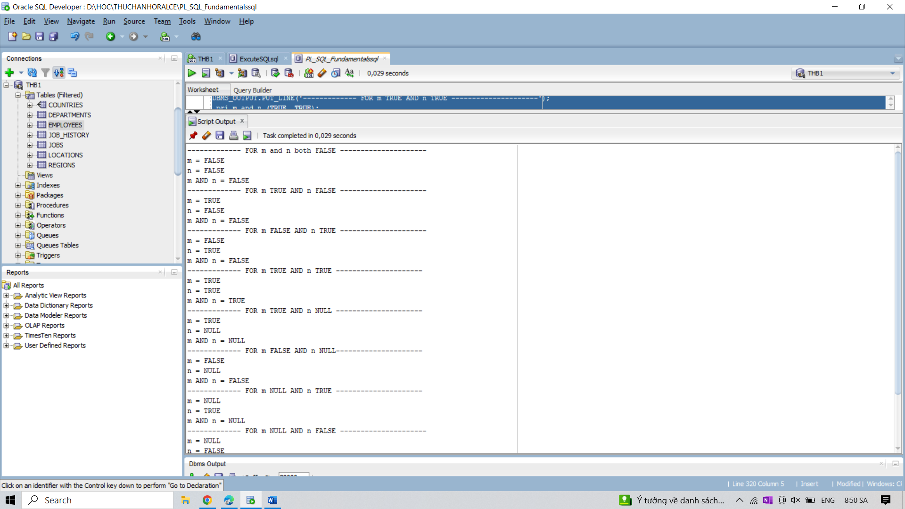

13. Write a PL/SQL block to create a procedure using the &quot;IS [NOT] NULL Operator&quot; and show

OR operator returns TRUE if either operand is TRUE.

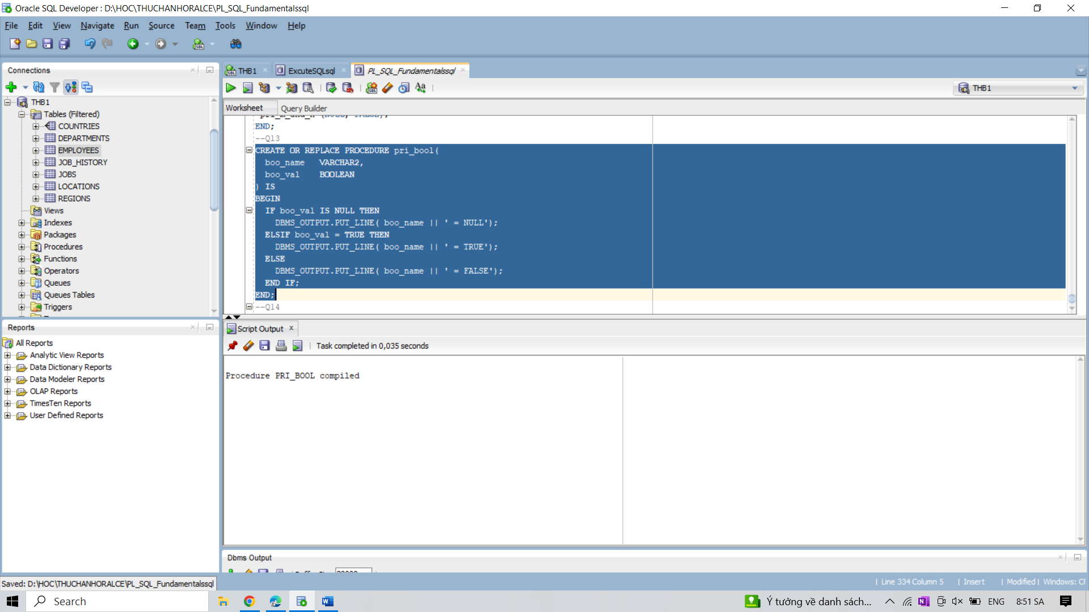

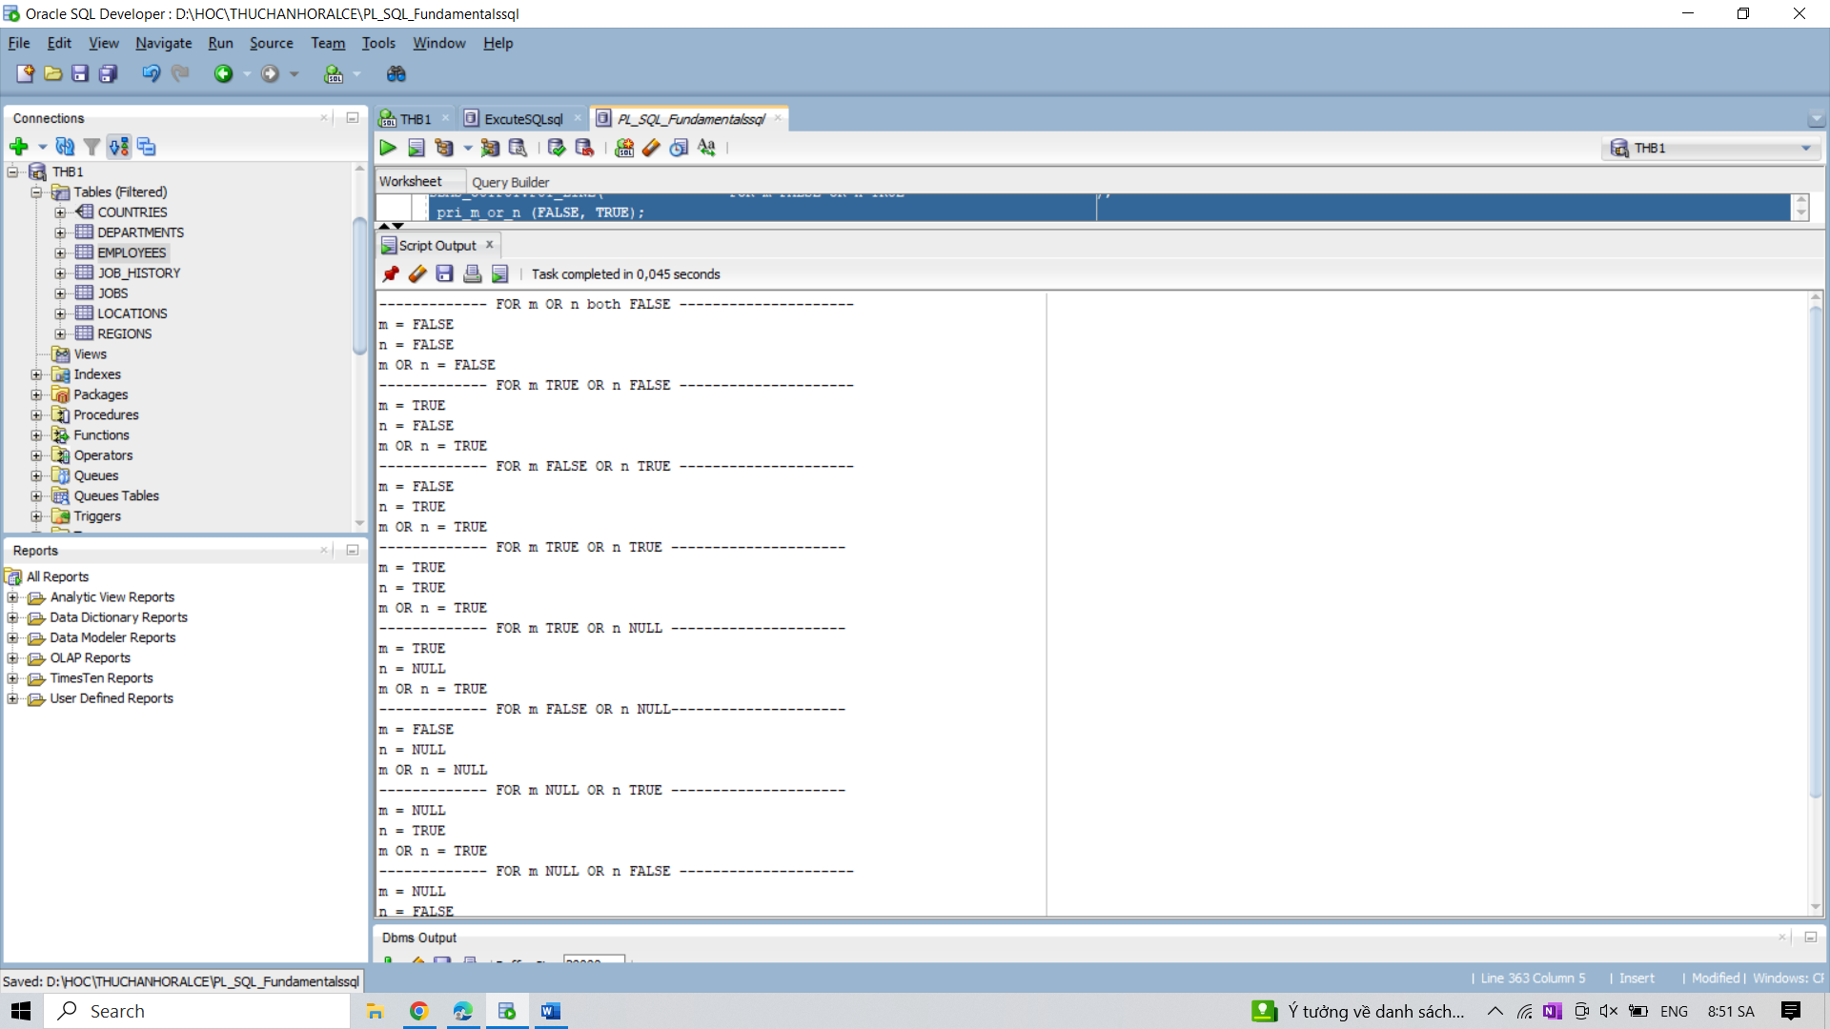

14. Write a PL/SQL block to create a procedure using the &quot;IS [NOT] NULL Operator&quot; and show

NOT operator returns the opposite of its operand, unless the operand is NULL.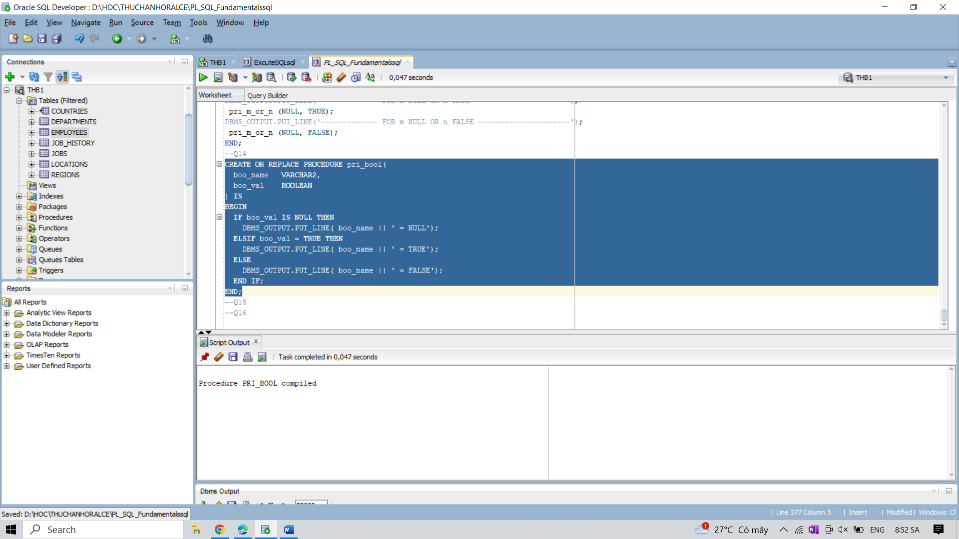

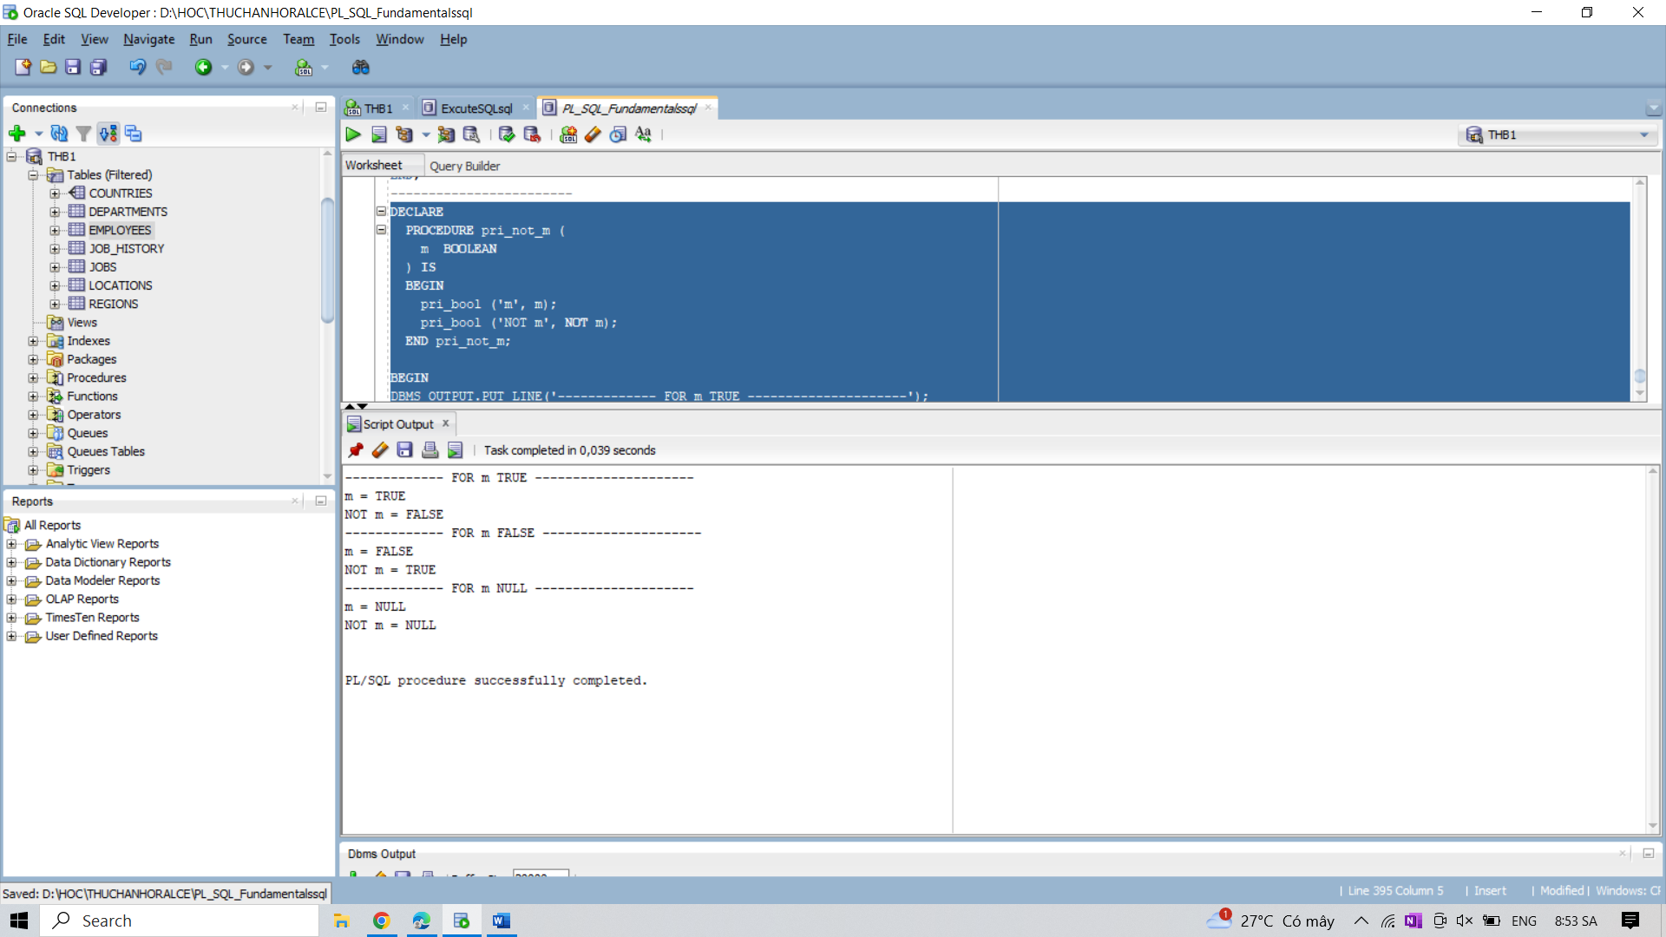

15. Write a PL/SQL block to describe the usage of NULL values in equal comparison, unequal

comparison and NOT NULL equals NULL comparison.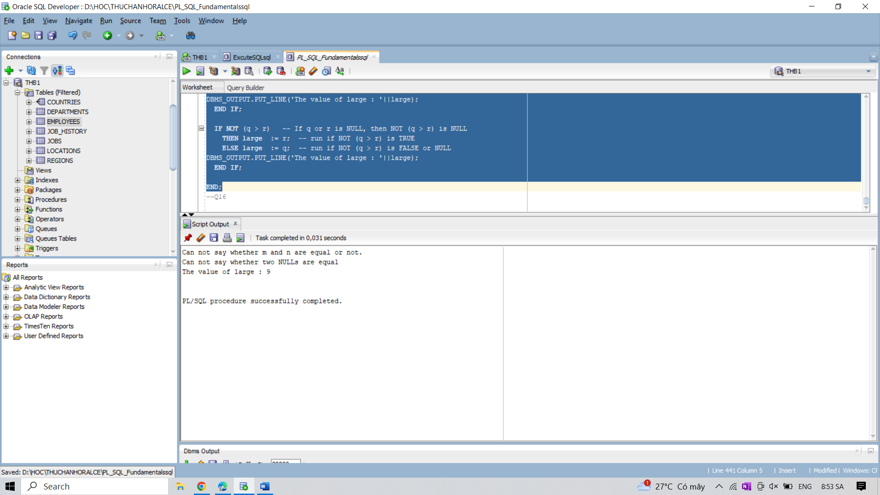

16. Write a PL/SQL block to describe the usage of LIKE operator including wildcard characters

and escape character.